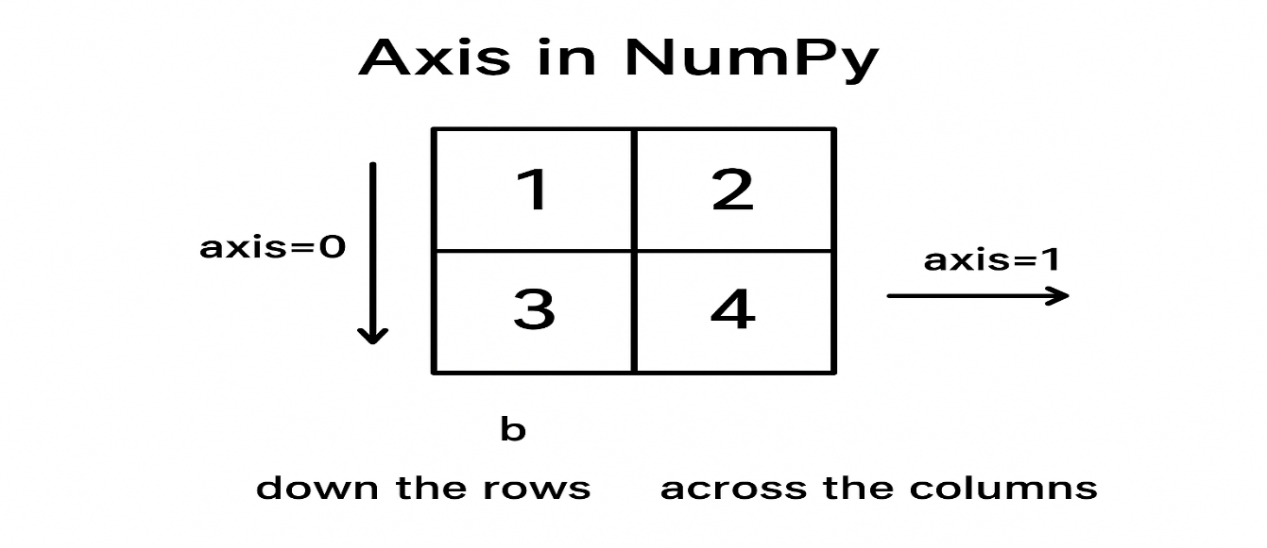

Axis | Direction | Meaning
axis = 0 | ↓ down the rows | Column-wise operation
axis = 1 | → across the columns | Row-wise operation

import numpy as np
array1 = [[1, 2], [3, 4]]

array2 = np.prod(array1, axis=1)
print(array2)
✔ axis = 1 → multiply across each row
Row 1: 1 × 2 = 2
Row 2: 3 × 4 = 12

Output:
[ 2 12 ]

📌 If axis = 0
np.prod(array1, axis=0)
This multiplies column-wise:

Column 1: 1 × 3 = 3
Column 2: 2 × 4 = 8

Output:

[3 8]
🎯 Simple Memory Trick
axis = 0 → operate DOWN
(because rows go downward)

axis = 1 → operate ACROSS
(because columns go left → right)

